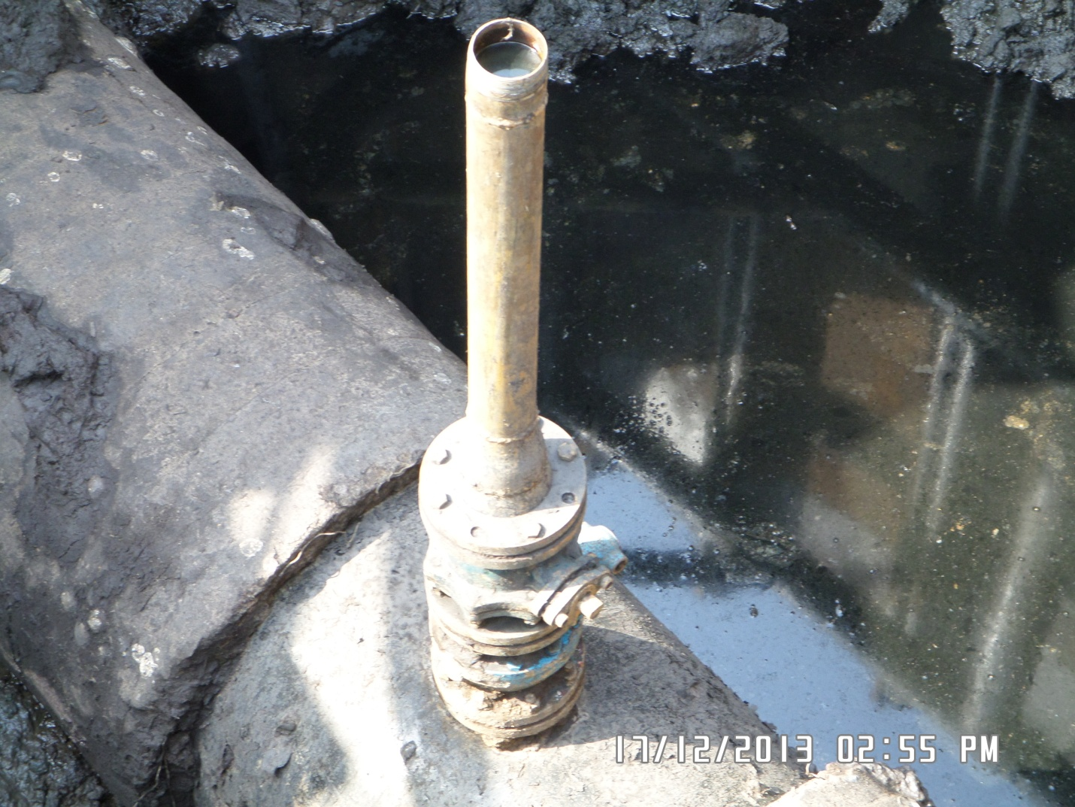
POINT OF INCIDENT AT TIGERKIRI

